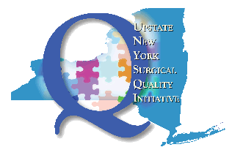

Upstate New York Surgical Quality Initiative (UNYSQI)

Chronic Substance Use Disorder Resources

- NYS Written Treatment Plan for Opioid Prescribing: Effective April 1, 2018, a written treatment plan in the patient’s medical record is required if a practitioner prescribes opioids for pain that has lasted for more than three months or past the time of normal tissue healing. https://www.health.ny.gov/professionals/narcotic/docs/opioid_treatment_plan_letter.pdf

- The NYS Bureau of Narcotic Enforcement (BNE) is responsible for protecting the public health by combating the illegal use and trafficking of prescription controlled substances. The Bureau also prevents prescription drug abuse through educational materials and presentations for parents, educators, and healthcare professionals.
https://www.health.ny.gov/professionals/narcotic/index.htm

- NYS HOPEline 1-877-8-HOPENY provides comprehensive information on treatment, prevention, and regulations. Includes a searchable listing of available treatment beds at NYS OASAS-certified substance use disorder treatment facilities.

- SAMHSA’s National Helpline, 1-800-662-HELP (4357), (also known as the Treatment Referral Routing Service) or TTY: 1-800-487-4889 is a confidential, free, 24-hour-a-day, 365-day-a-year, information service, in English and Spanish, for individuals and family members facing mental and/or substance use disorders. This service provides referrals to local treatment facilities, support groups, and community-based organizations. Callers can also order free publications and other information.
https://www.samhsa.gov/find-help/national-helpline

- 211 is the most comprehensive source of local human and social services information in the US and Canada. Highly trained specialists are available 24/7 via telephone or internet to help patients and families access services to address any need including opioid crisis intervention, support groups, counseling and more. Dial 211 or 1-877-356-9211
http://www.211.org/

- HANYS curated listing of programs and resources for hospitals, healthcare providers, patient advocates and members of the public as they work to treat individuals addicted to opioids and help to prevent overdose occurrences. https://www.hanys.org/quality/collaboratives_and_learning_networks/opioids/addiction_treatment/

